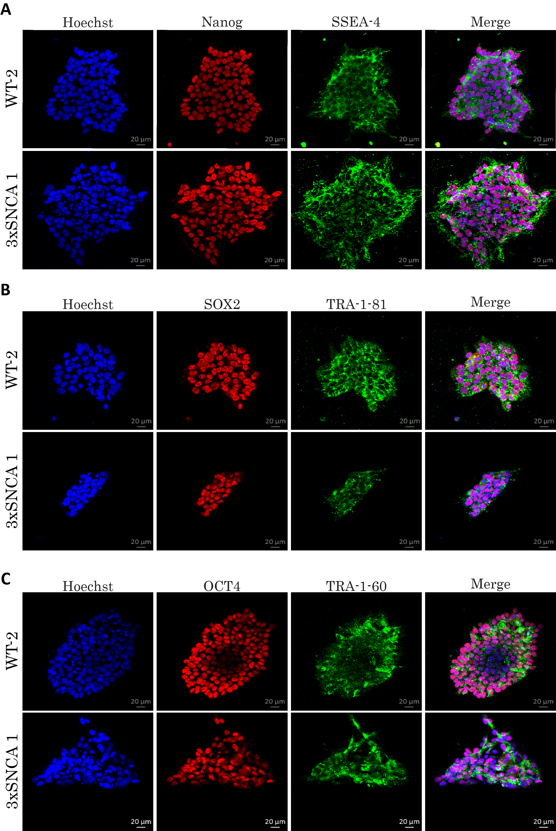
Supplementary Figure 1. Characterization of iPSC. Representative immunofluorescence stainings of WT-1 and SNCA-1 lines showing expression of (A) Nanog and SSEA4 (B) SOX2 and TRA-1-81(C) OCT4 and TRA-1-60. Scale bar = 20µm

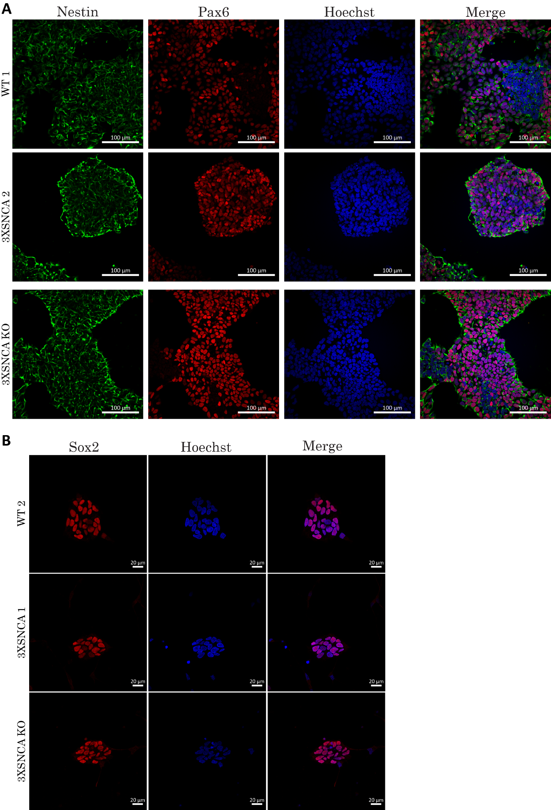
Supplementary Figure 2. Characterization of NESC. Representative immunofluorescence stainings of WT-2, SNCA-2 and SNCA KO lines showing expression of (A) Nestin, Pax6 (Scaled bar = 100µm) and (B) Sox2 (Scale bar = 20µm).

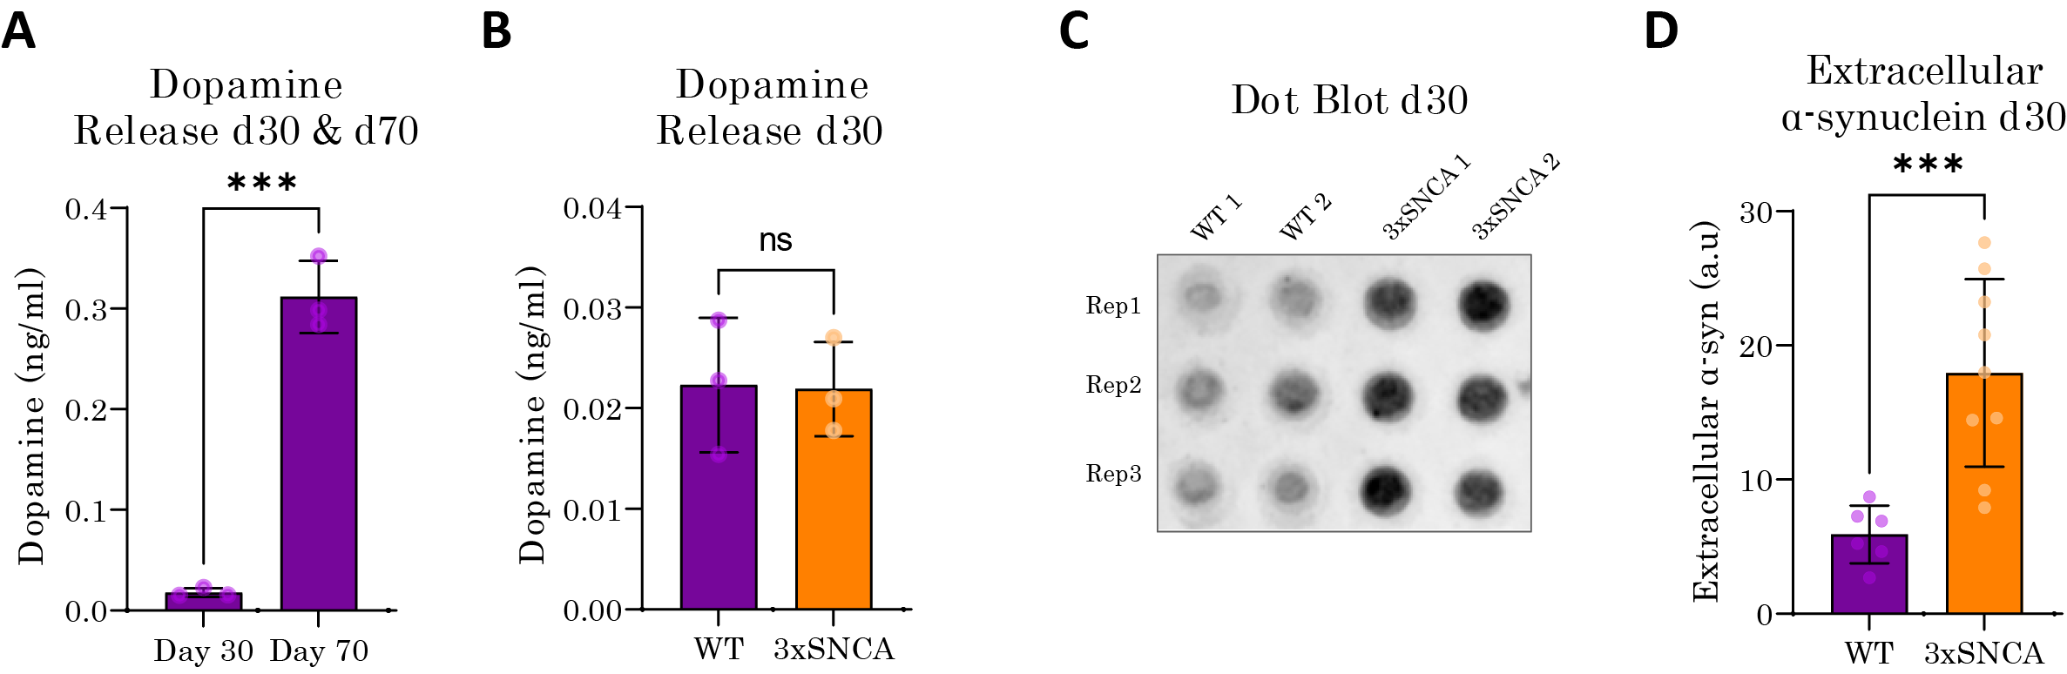
Supplementary Figure 3. Extracellular release of dopamine and α-synuclein. (A) WT hMO release increasing amounts of dopamine over time, as quantified at 30 and 70 days of organoid maturation as determined by dopamine ELISA. Data is from three independent organoid batches. Statistical significance by Mann-Whitney U test: ***p < 0.001. (B) There is no difference in dopamine release between 3xSNCA and WT hMO at 30 days of organoid maturation as determined by dopamine ELISA. Data is from three independent organoid batches. Statistical significance by Mann-Whitney U test: not significant (C) Representative dot blot of extracellular α-synuclein at 30 days of organoid maturation. Rep = replicate. Dot blot is cropped from original image found in Supplementary Original Blots. (D) Quantification of extracellular α-synuclein release at 30 days of organoid maturation. Data represents points represents results from media collected from individual organoids from three independent hMO batches, N = 2-3 hMO per line. Statistical significance by Mann-Whitney U test: ***p < 0.001.

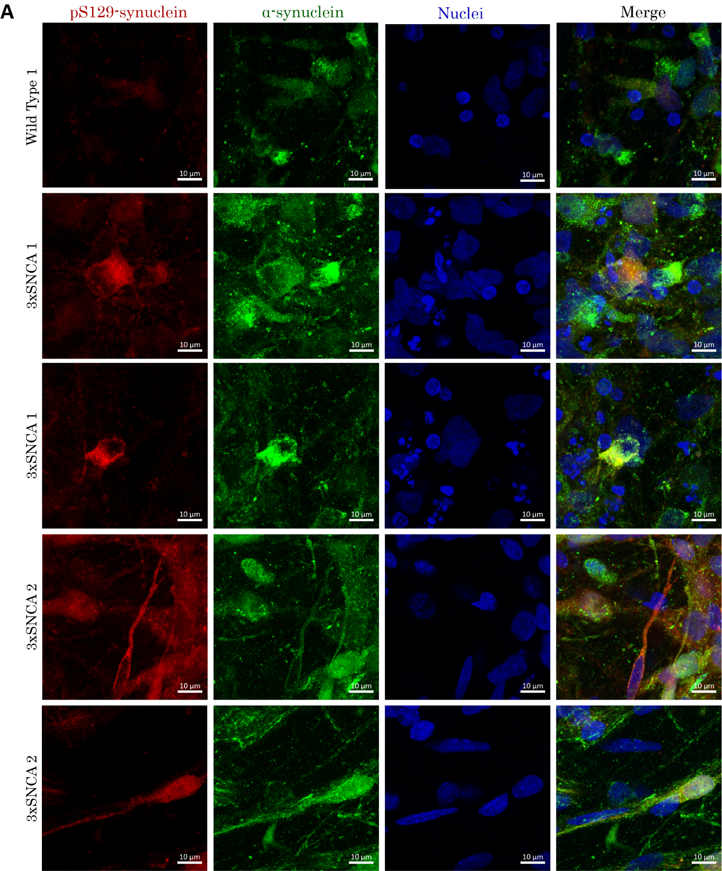
Supplementary Figure 4. 3xSNCA hMO recapitulate α-synuclein aggregation pathology. (A)Representative images of 30-day old hMO stained with pS129 α-synuclein (red) and total α-synuclein (green). 3xSNCA hMO show presence of aggregate-like structures rich in pS129 α-synuclein. Scale bar = 10µm.

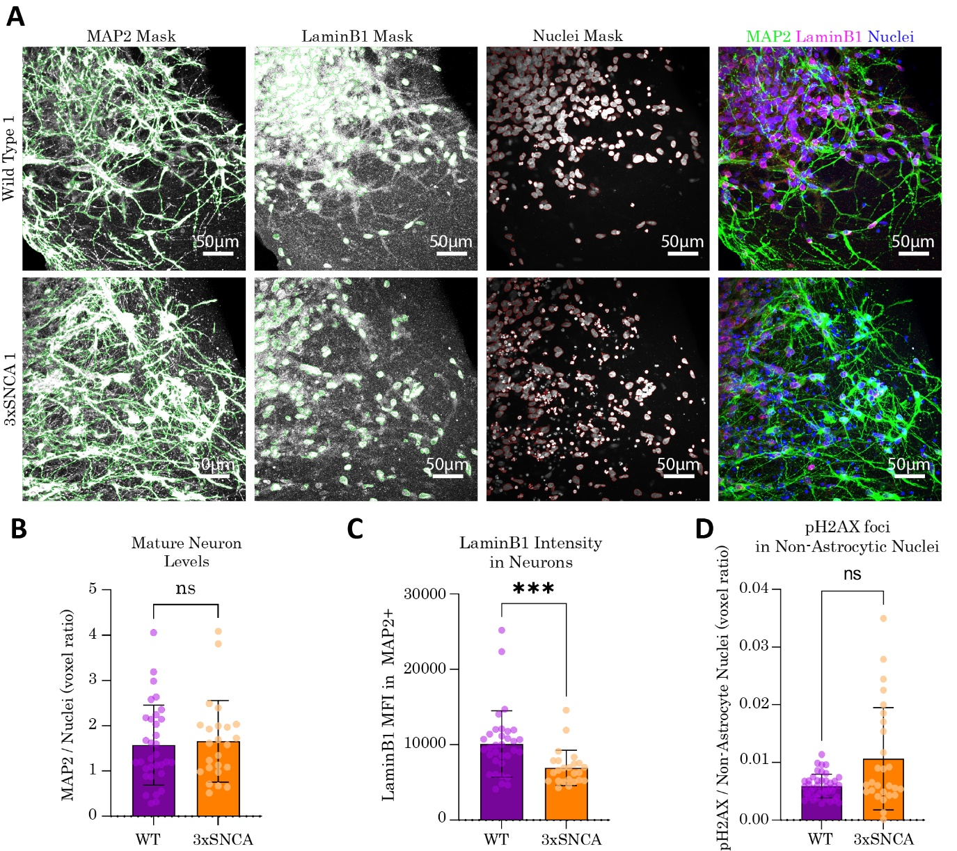
Supplementary Figure 5. Neurons in 3xSNCA hMO show nuclear lamina deficits but not increased senescence associated heterochromatin foci (A) Representative images obtained from confocal imaging of 50-day old hMO sections at 40X magnification showing MAP2, lamin B1 and nuclei masks as identified by a Matlab image analysis script. Scale bar = 50µm. (B) Quantification of MAP2+ cells at 50 days revealed no differences in neuronal levels between WT and 3xSNCA hMO. Data is from three independent organoid batches. N = 3-4 organoids per batch. 3-6 sections were analyzed per organoid. N(WT) = 33. N(3xSNCA) = 24. Statistical significance by Mann-Whitney U test: not significant. (C) The expression of lamin B1 was significantly reduced in 3xSNCA hMO neurons at 50 days of organoid maturation. Data is from three independent organoid batches. N = 3-4 organoids per batch. 3-6 sections were analyzed per organoid. N(WT) = 33. N(3xSNCA) = 24. Statistical significance by Mann-Whitney U test: ***p < 0.001. MFI – mean fluorescence intensity. (D) There was no significant difference in pH2AX foci present in non-astrocytic nuclei in 3xSNCA hMO astrocyte nuclei at 70 days of organoid maturation. Data is from three independent organoid batches. N = 3-4 organoids per batch. 3-6 sections were analyzed per organoid. N(WT) = 42. N(3xSNCA) = 28. Statistical significance by Mann-Whitney U test: *p < 0.05.

