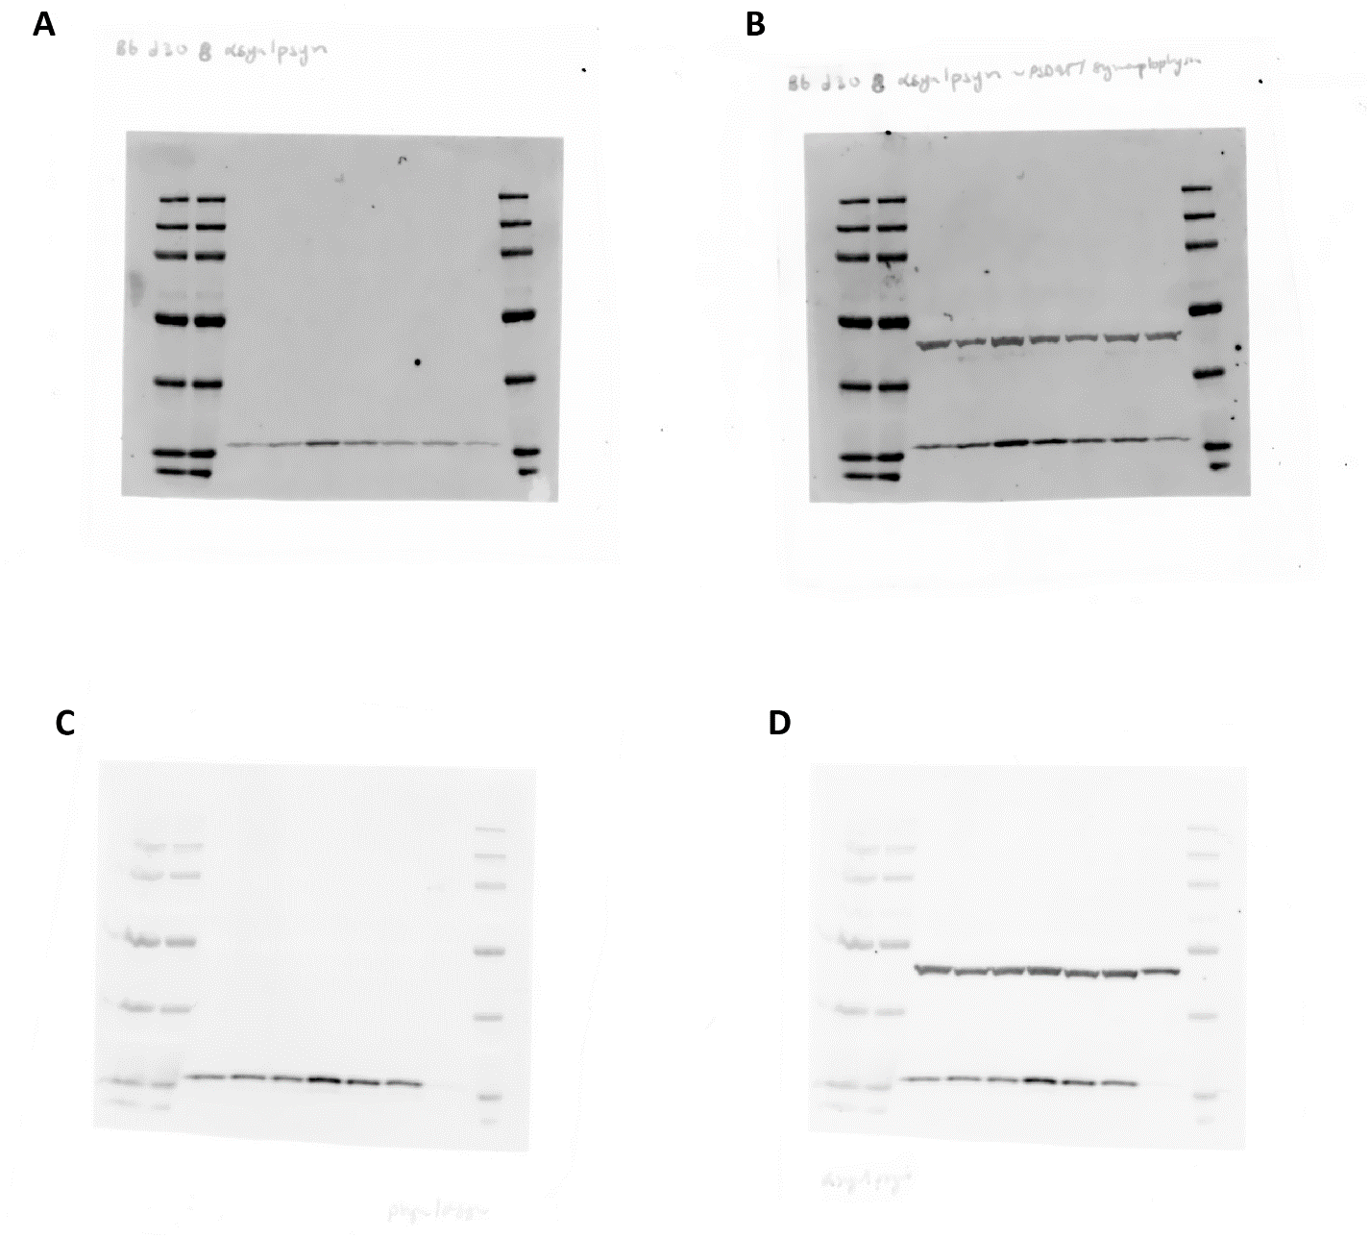
Supplementary Blots Figure 1. Original Western Blots in Figure 2A
(A) α-synuclein (14kDa) day 30
(B) α-synuclein (14kDa) and ß-actin (42kDa) day 30
(C) α-synuclein (14kDa) day 70
(D) α-synuclein (14kDa) and ß-actin (42kDa) day 70
Order of loading of Western blot: Ladder, Ladder, WT 201 (WT-1), WT 232 (WT-2), 3xSNCA 317 (3xSNCA-1), 3xSNCA 336 (3xSNCA-2), 3xSNCA 392, GC 373, GC 391, Ladder.
3xSNCA 392, GC 373 and GC 391 were excluded from this study.
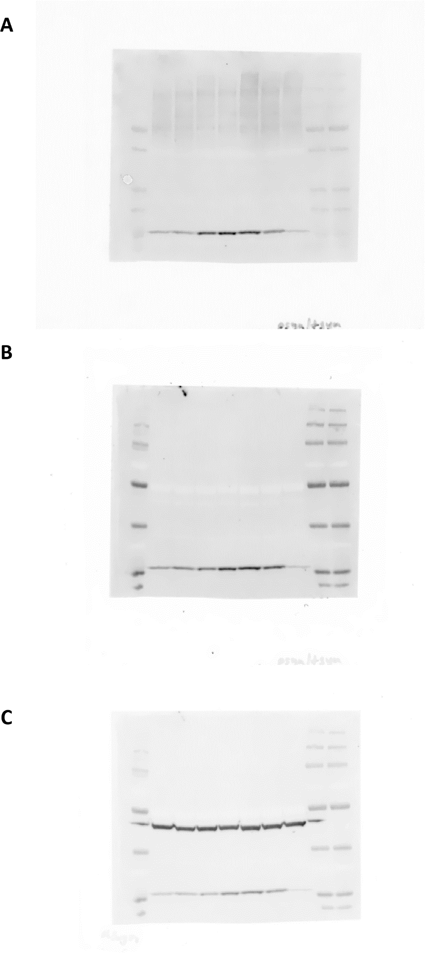
Supplementary Blots Figure 2. Original Western Blots in Figure 3A
(A) pS129 α-synuclein (14kDa) day 50
(B) α-synuclein (14kDa) day 50
(C) α-synuclein (14kDa) and ß-actin (42kDa) day 50
Order of loading of Western blot: Ladder, WT 201 (WT-1), WT 232 (WT-2), 3xSNCA 317 (3xSNCA-1), 3xSNCA 336 (3xSNCA-2), 3xSNCA 392, GC 373, GC 391, Ladder, Ladder.
3xSNCA 392, GC 373 and GC 391 were excluded from this study.

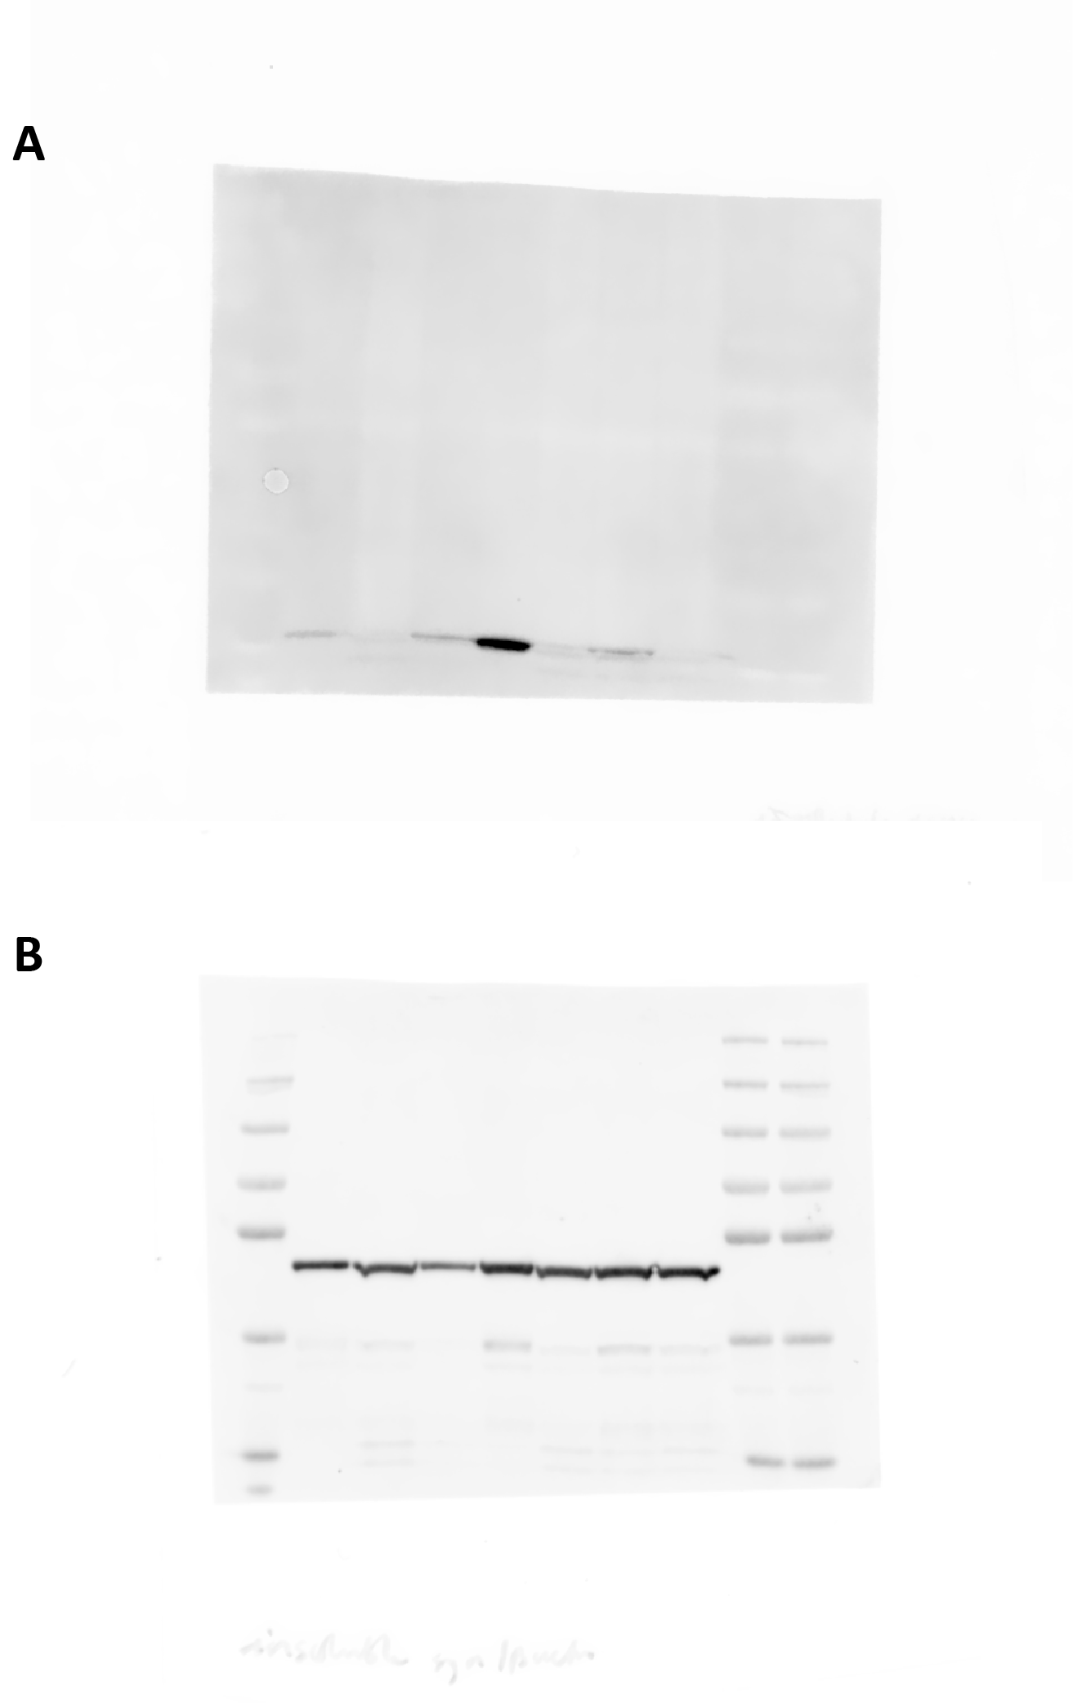
Supplementary Blots Figure 3. Original Western Blots in Figure 3E
(A) α-synuclein (14kDa) day 50
(B) ß-actin (42kDa) day 50
Order of loading of Western blot: Ladder, WT 201 (WT-1), WT 232 (WT-2), 3xSNCA 317 (3xSNCA-1), 3xSNCA 336 (3xSNCA-2), 3xSNCA 392, GC 373, GC 391, Ladder, Ladder.
3xSNCA 392, GC 373 and GC 391 were excluded from this study.

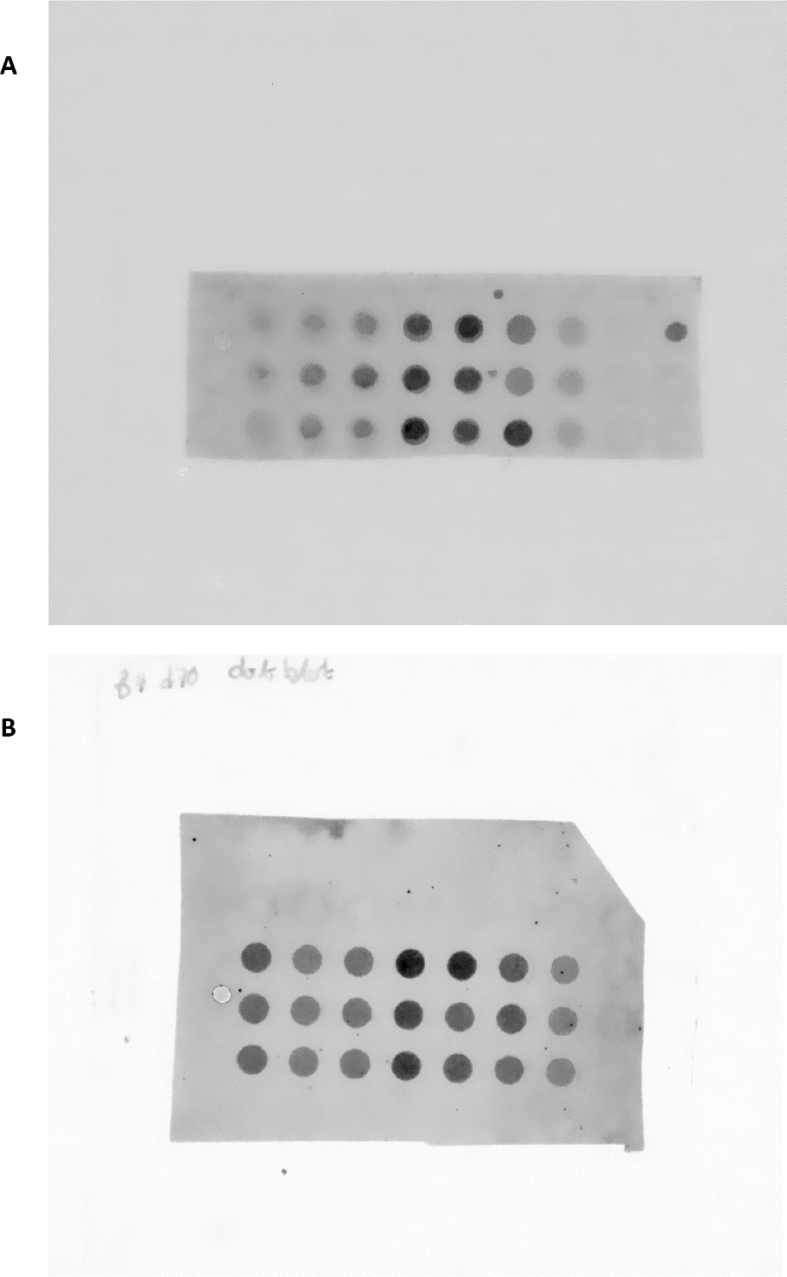
Supplementary Blots Figure 4.
(A) α-synuclein dot blot day 30 – used in Supplementary Figure 3C
(B) α-synuclein dot blot day 70 – used in Figure 2D
Order of loading of both dot blots: GC 391, WT 201 (WT-1), WT 232 (WT-2), 3xSNCA 317 (3xSNCA-1), 3xSNCA 336 (3xSNCA-2), 3xSNCA 392, GC 373. Each row represents independent replicates. 3xSNCA 392, GC 373 and GC 391 were excluded from this study.
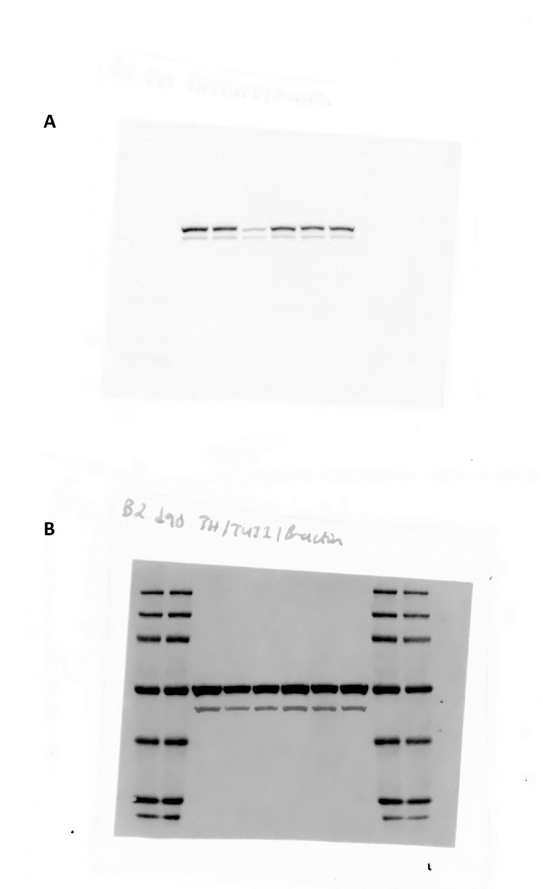
Supplementary Blots Figure 5. Original Western Blots in Figure 4C
(A) TH (60kDa) day 90
(B) ßIII-Tubulin (50-55kDa) and ß-actin (42kDa) day 90
Order of loading of Western blot: Ladder, Ladder, WT 201 (WT-1), WT 232 (WT-2), 3xSNCA 317 (3xSNCA-1), 3xSNCA 336 (3xSNCA-2), 3xSNCA 392, GC 373, Ladder, Ladder.
3xSNCA 392, GC 373 and GC 391 were excluded from this study.

